Name: Period:
Using the Harry Potter Lexicon site, fill out the following information:
1. Define the following science terms in your own words:
Inherited Traits:

Acquired Traits:

2. Pick one character from the Harry Potter series.
Write their name here:
3. Research the character, (go to: http://www.hp-lexicon.org/gate/characters.html )
4. Make a list of 5 inherited traits that this character has:
a. b.
c. d.
e.
5. Make a list of 5 acquired traits that this character has: 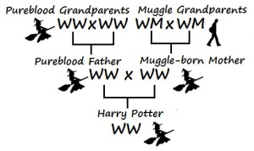
a. b.
c. d.
e.

6. Now pick 5 different characters from the site, fill in the chart below with the traits that each has acquired and inherited:
Name | Witch or Wizard | Muggle or Half-Blood | Interested in the Dark Arts | Has Fears | Able to Teach | Black Hair | Blue Eyes | Trusted Friend

7. Which of the above traits are inherited and which are acquired traits?
Inherited Traits Acquired Traits

8. Now make a list of 5 of your acquired traits:
a. b.
c. d.
e.

9. Now make a list of 5 of your inherited traits:
a. b.
c. d.
e.

10. What inherited traits do you think you will pass on to your children, explain the science behind it (Hint: Punnett Square)

11. What acquired traits do you think you will pass on to your children, explain your reasoning.

