5
Activity

PART TWO

Battle of the beaks
Medium ground ﬁnches eat a range of food including about two dozen kinds of seeds. These seeds range from small soft ones to seeds in hard shells that are tough to open. One of the toughest seeds on Daphne is from a plant called Tribulus. The seeds from Tribulus are about eight times harder to open than the soft seeds that ﬁnches also eat.
In North America Tribulus is a common weed that produces some of the tough- est, meanest seeds around. Sometimes it is called puncture vine because the seeds have a talent for jamming themselves into bare ﬂesh and bicycle tires.
Finches eat the easy food ﬁrst. When soft seeds are plentiful the ﬁnches dine on those. When soft seeds are not available, the ﬁnches resort to the harder-to-open seeds. The scientists on Daphne Major observed that only ﬁnches with bigger beaks are able to crack open the tough seeds like Tribulus to get the food inside.
In this activity you will build two diﬀerent types of beaks and test their food-nab- bing eﬀectiveness. Find out in the game of survival whether beak size matters.

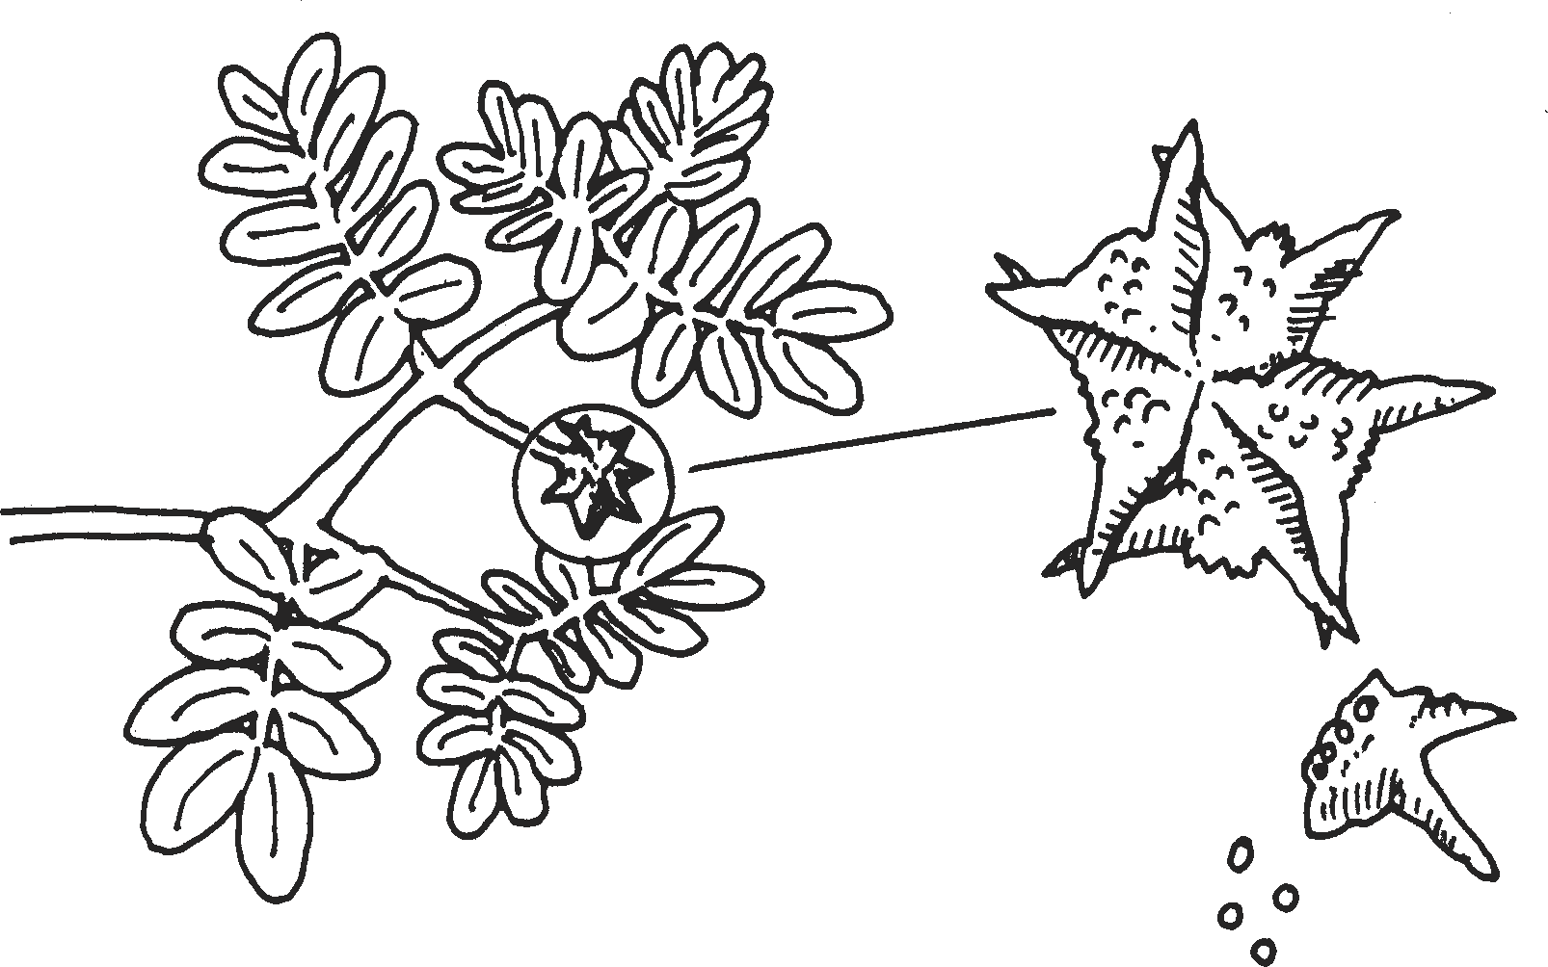
Tribulus
Linda Allison illustration

5
Activity

Work with a partner
Each team will need:
- Battle of the Beaks: Normal Year Chart
- Battle of the Beaks: Drought Year Chart
- beak materials: 4 popsicle sticks, 2 rubber bands, 9 pennies
- food supply: 1 teaspoon large seeds (e.g., garbanzos) and 1 teaspoon small seeds (e.g., mustard seeds)
- cm ruler
- tape
- sheet of paper (“stomach”)
- paper plate (“island”)
- timer

1 Build a Small Beak
Use popsicle sticks to test the diﬀerence between big beaks and small beaks.
- To build a small beak, you will need two popsicle sticks, a rubber band,

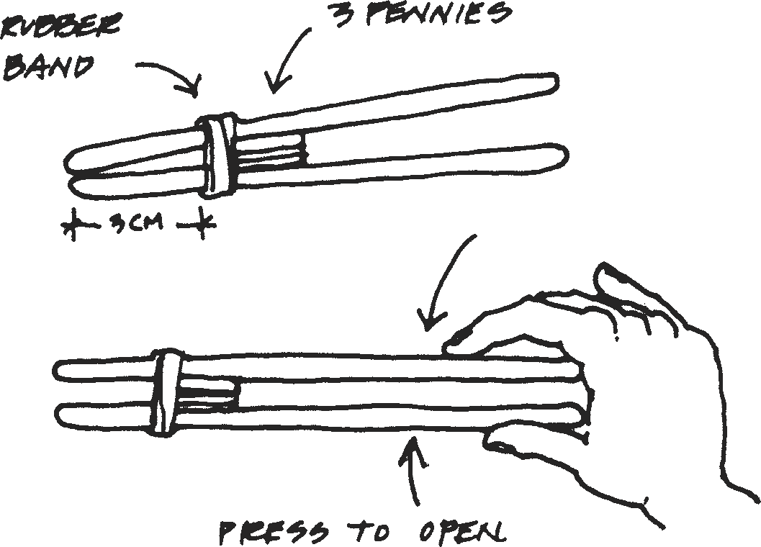
and three pennies.
- Measure and mark a stick with a line 3 centimeters from the tip.
- Rubber band the two sticks together just past the 3 centimeter line.
- Make a stack of three pennies. Hold the stack together with a skinny piece of tape.
- Slide the stack of pennies between the two sticks. Position them just behind the rubber band.

Rubber band
3 pennies

Press to open
3 cm

- Press on the open ends to open the beak.

2 Build a Big Beak
- To build a big beak you need two popsicle sticks, a rubber band, and six pen- nies. Measure and mark a stick with a line 6 centimeters from the tip.
- Rubber band the two sticks together just past the 6 centimeter line.
- Make a stack of six pennies. Hold the stack together with a skinny piece of tape. Slide the stack of pennies between the two sticks. Position them just behind the rubber band.
- Press on the open ends to open the beak.

5
Activity

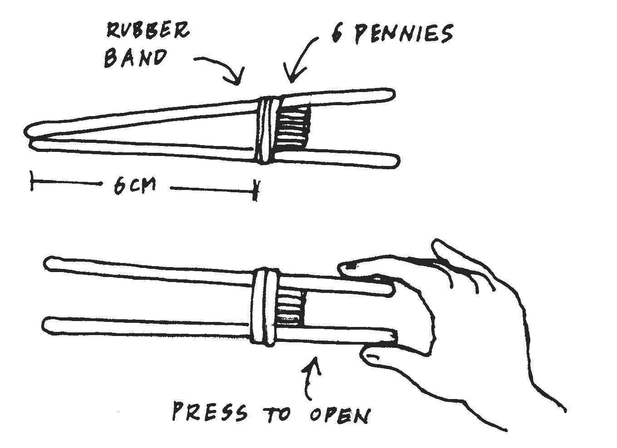
Beak Testing: A Normal Year
Rubber band
6 pennies
6 cm
Press to open
In this test your ﬁnch stays alive by gathering seeds on the “island” and collecting them in your “stomach.” You will have one minute to gather up as much food as you can.
  - Decide who will use the big beak and who will use the small beak. Write each name on the Battle of the Beaks: Normal Year Chart.
  - Before you start, predict which beak will be the better tool for gather- ing seeds:

  - In a normal year, there is a mix of large and small seeds. Prepare a seed supply for a normal year grabbing an equal pile of large and small seeds then scat- tering them on the island (the paper plate). Each beak needs a sheet of paper to act as a stomach for its seeds.
  - Grab a few seeds and practice with your beak.
  - Decide who will be the timer and who will be the beak tester.
  - Ready to test? When the timer says go the tester will have one minute to use the beak to put as many seeds as possible in the stomach.
  - When the minute is up, count the seeds that you gathered. Record the performance for your beak on the Battle of the Beaks: Normal Year Chart. Repeat the exercise for test #2.

5
Activity

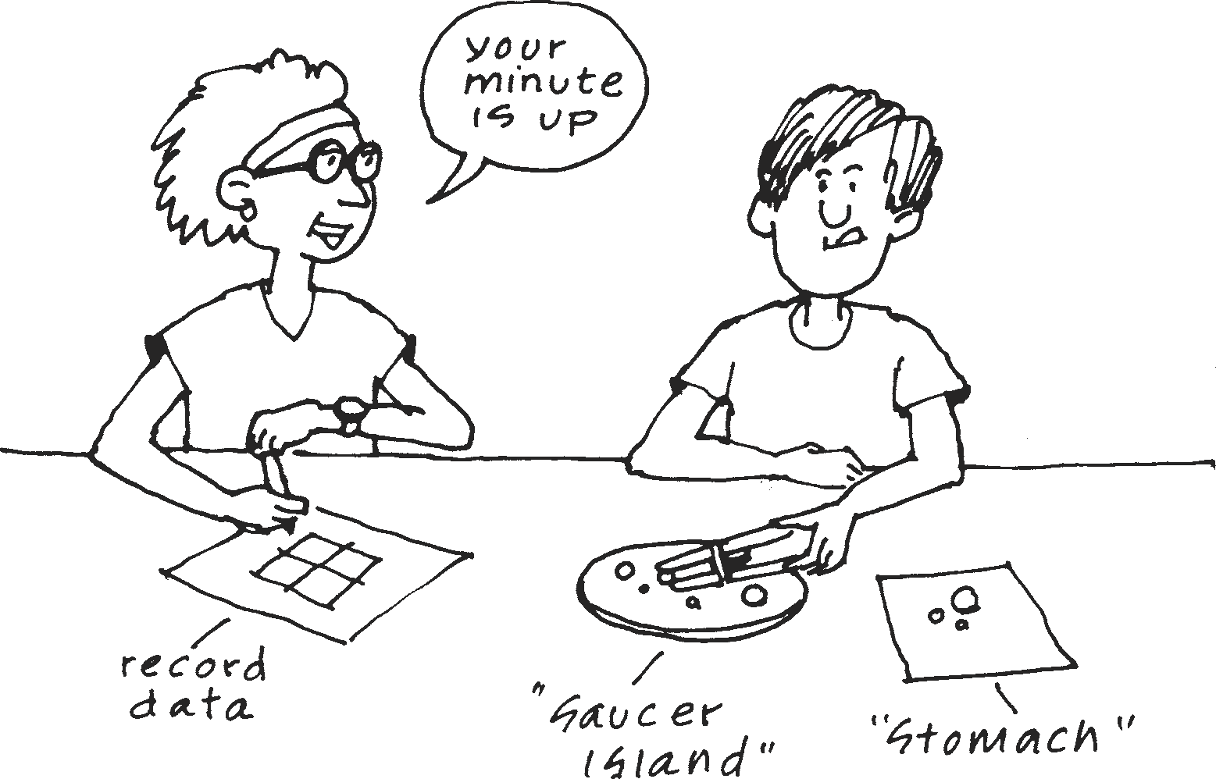
Your minute is up.

Record data

“Saucer Island” “Stomach”

Battle of the Beaks: Normal Year Chart
Beak Type | Normal Year (A Mix of Seeds)
Small Beak  Name of tester: | Test # 1
 | Test # 2
 | Total
Big Beak  Name of tester: | Test # 1
 | Test # 2
 | Total

  - Switch places and have your partner complete Test 1 and Test 2 for the other beak size.
  - Add up the totals and record them on the Battle of the Beaks: Normal Year Chart. Which beak size gathered the most seeds?

5
Activity

Beak Testing: A Drought Year
One year no rain came to the island. Many plants failed to bloom and produce new seeds. All the medium ground ﬁnches ate the small, soft seeds ﬁrst, leaving mostly large, tough seeds, so now big seeds dominate the menu.
- Prepare a seed supply for a drought year by leaving mostly large seeds and only two or three small seeds on the island.
- Repeat the steps you did for the Normal Year. You and your partner should complete Test 3 and 4 for both beak sizes. Record your data under Battle of the Beaks: Drought Year Chart.

Battle of the Beaks: Drought Year Chart
Beak Type | Drought Year  ( Mostly big, tough seeds)
Small Beak  Name of tester: | Test # 3
 | Test # 4
 | Total
Big Beak  Name of tester: | Test # 3
 | Test # 4
 | Total

- Add up the totals and record them on the Drought Year Chart. Which beak size gathered the most seeds?

5
Activity

Review the Data
- Which beak size gathered the most seeds in a normal year?

- Which beak size gathered the most seeds in a drought year?

- Review your prediction under 3b (page 137) (Beak Testing: A Normal Year).
Was your prediction correct or not?

- How does a change in environment (drought) aﬀect which beak size gathers the most seeds?

Consider This
“Natural selection” occurs when the environment favors or selects some varia- tions over others. You have tested two variations of beaks, large and small. In the drought environment, which beak variation is favored? Why?

