BODY SYSTEMS - THE FINAL ANSWER
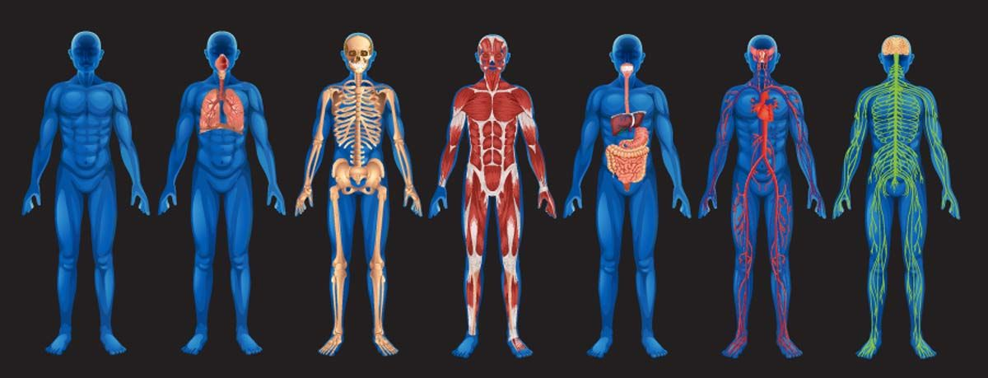

Name:

Class Period:

STUDENT LEARNING OBJECTIVE:
Students will demonstrate what they have learned about the various body systems found in humans.

INSTRUCTIONS:
- Pick 4 of the body systems listed below and answer the questions that go with those particular body systems.
- BE SURE TO WRITE YOUR ANSWERS USING COMPLETE SENTENCES!!!
- You must answer all of the questions for a system for it to count for your 4 systems.
- To earn Exemplary, you will need to answer questions for 5 or more systems.
- Show us what you know!

Digestive System:

- What is the major purpose of the digestive system? EXPLAIN.

- What enters the digestive system and what exits the digestive system?

- What system or systems does the digestive system work with? EXPLAIN.

Circulatory System:

- What is one of the major purposes of the Circulatory system? EXPLAIN.

- What enters the Circulatory system and what exits the Circulatory system?

- What system or systems does the Circulatory system work with? EXPLAIN.

Excretory System:
- What is the major purpose of the Excretory system? EXPLAIN.

- What enters the Excretory system and what exits the Excretory system?

- What system or systems does the Excretory system work with? EXPLAIN.

Endocrine System:
- What is the major purpose of the Endocrine system? EXPLAIN.

- What enters the Endocrine system and what exits the Endocrine system?

- What system or systems does the Excretory system work with? EXPLAIN.
Respiratory System:
- What is one of the major purposes of the Respiratory system? EXPLAIN.

- What enters the Respiratory system and what exits the Respiratory system?

- What system or systems does the Respiratory system work with? EXPLAIN.

Skeletal System:
- What is one of the major purposes of the Skeletal system? EXPLAIN.

- What enters the Skeletal system and what exits the Skeletal system?

- What system or systems does the Skeletal system work with? EXPLAIN.
Muscular System:
- What is the major purpose of the Muscular system? EXPLAIN.

- What enters the Muscular system and what exits the Muscular system?

- What system or systems does the Muscular system work with? EXPLAIN.

Nervous System:
- What is the major purpose of the Nervous system? EXPLAIN.

- What enters the Nervous system and what exits the Nervous system?

- What system or systems does the Nervous system work with? EXPLAIN.

Immune System:
- What is the major purpose of the Immune system? EXPLAIN.

- What enters the Immune system and what exits the Immune system?

- What system or systems does the Immune system work with? EXPLAIN.

