“Decoding Genes” Part 2

Read pages 8 – 27 of “Decoding Genes” and answer the questions below.

- Do you have dimples? If you do, do you have dominant or recessive alleles? If you don’t have dimples, do you have dominant or recessive alleles? (p.8)
ANSWER:
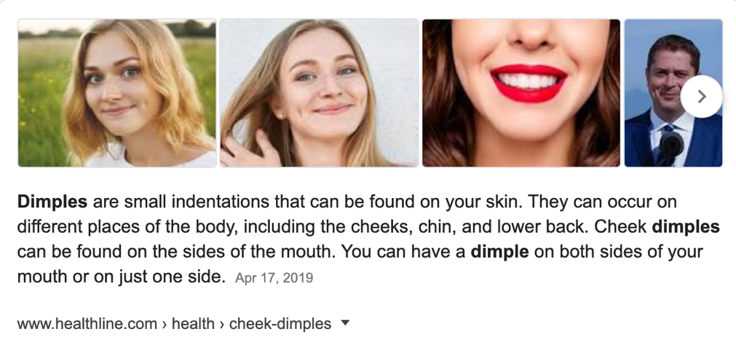

- Are all traits determined by a single gene? (p.9)
ANSWER:

- What do cells make? (p.10)
ANSWER:

- What do genes tell the cell? (p.10)
ANSWER:

- What do ribosomes do inside the cell? (p.10)
ANSWER:

- What does the nucleus contain and do? (p.10-11)
ANSWER:

- Where do your chromosomes come from and how many do you receive? (p.11)
ANSWER:

- What are genes made of? (p.11)
ANSWER:

- What are the four bases that make up our DNA? (p.12)
ANSWER:

- What do our genes make? (p.14)
ANSWER:

- What are proteins? (p.14)
ANSWER:

- Fill in the blanks from page 15:

“To recap, ________ is made of four chemical bases arranged in a ____________ spiral. Sections of DNA, called _____________, are code for ____________. Individual strands of _________, called
___________________, carry thousands of _________. All the strands of _________ together make up the _____________, the body’s entire ______________ makeup.

- How many genes does the human genome contain? (p.15)
ANSWER:

- What percent of human DNA is identical to chimpanzee DNA? (p. 16)
ANSWER:

- What causes the chimpanzees to be different from humans? (p.16)
ANSWER:

- What are mutations and how do they happen? (p. 17)
ANSWER:

- Are all mutations harmful to species? (p.17)
ANSWER:

- How do scientists use DNA samples, when trying to help salmon? (p. 24-25)
ANSWER:

- What are some of the areas that Genetic discoveries have influenced? (p.26)
ANSWER:

- Do genes make us the same or different? Explain. (p.27)
ANSWER:

- Write down two interesting facts from pages 28 – 29:

FACT#1:

FACT#2:

