DNA Mutation Activity

NAME: __________________________ Class Period: __
PART ONE Directions:

- Compare the original DNA sequence to the mutated DNA sequence.
- Circle or underline the part of the mutated DNA sequence (or original, if the original has more bases than the mutated sequence) that is different from the original DNA sequence.
- Identify each mutation according to the type of mutation it is, your choices are:
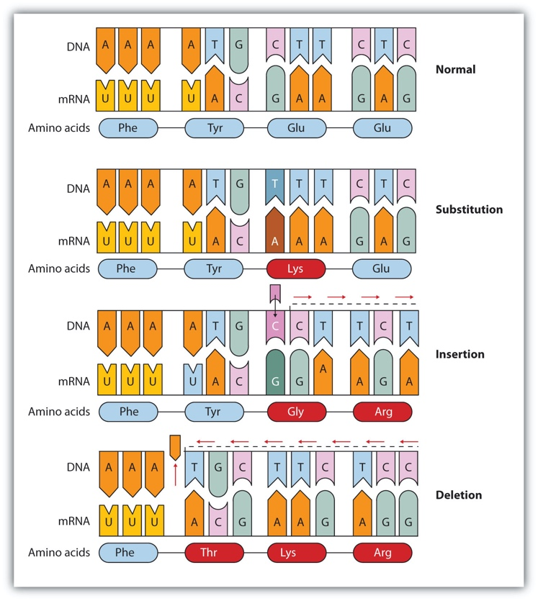
  - Simple Point Insertion is when a genetic mutation is caused by an amino acid (A,C,T,G) being inserted or added to the sequence, changing the base pair

  - Simple Point Substitution is when a genetic mutation is caused by an amino acid (A, C, T, G) being substituted in the sequence, changing the base pair

  - Frameshift mutation is when is a genetic mutation is caused by a deletion in a DNA sequence that shifts the way the sequence is read.

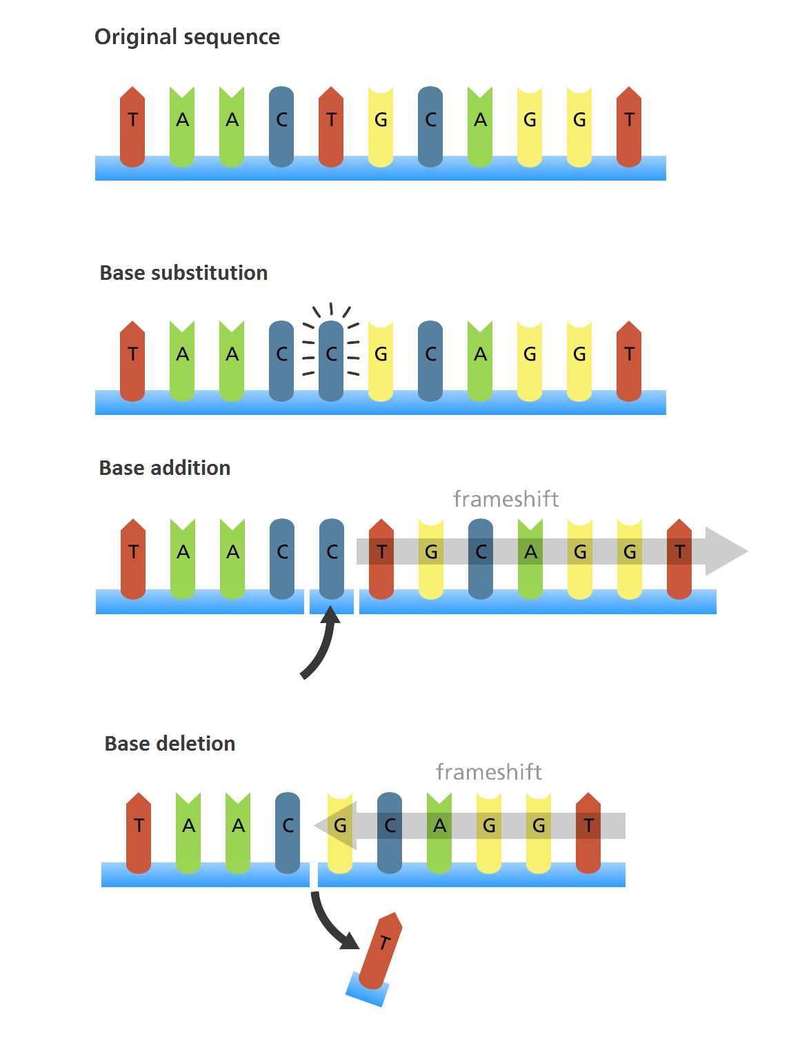

For example:

Original DNA Sequence: GATGCGATCAGCCTGA
Mutated DNA Sequence: GATGCGATCATGA
Mutation Type: Simple Insertion

1) Original DNA Sequence:  AGTCATGGCCATCGCCTAG  Mutated DNA Sequence:  AGTCATGGCAATCGCCTAG  Mutation Type: _____________________ | 2) Original DNA Sequence:  ATCATGCGCCAAATACGGTGA  Mutated DNA Sequence:  ATCATGCGCCATACGGTGA  Mutation Type: _____________________ | 3) Original DNA Sequence:  GCCATCATGCGCTTTTGA  Mutated DNA Sequence:  GCCATCATGCGCTGA  Mutation Type: _____________________
4) Original DNA Sequence:  AAAATGCGCTTACGATGA  Mutated DNA Sequence:  AAAATGCGCTCCCTACGATGA  Mutation Type: _____________________ | 5) Original DNA Sequence:  AGTCATGGCATCGCCTAG  Mutated DNA Sequence:  AGTCATGGCAATCGCCTAG  Mutation Type: _____________________ | 6) Original DNA Sequence:  ATCATGCGCCAAATACGGTGA  Mutated DNA Sequence:  ATCATGCGCCTACGGTGA  Mutation Type: _____________________
7) Original DNA Sequence:  GCCATCATGCGCTTTTGA  Mutated DNA Sequence:  GCCATCATGCGCTTCTGA  Mutation Type: _____________________ | 8) Original DNA Sequence:  AAAATGCGCTTACGATGA  Mutated DNA Sequence:  AAAATGCGCTTACGACGATGA  Mutation Type: _____________________ | 9) Original DNA Sequence:  AGTCATGGCATCGCCTAG  Mutated DNA Sequence:  AGTCATGTTCGCCTAG  Mutation Type: _____________________
10) Original DNA Sequence:  AATGCGCTTTTGA  Mutated DNA Sequence:  AATGCGGTTCTGA  Mutation Type: _____________________ | 11) Original DNA Sequence:  AATGCGCTTTTGA  Mutated DNA Sequence:  AATGCGCAAGTTCTGA  Mutation Type: _____________________ | 12) Original DNA Sequence:  AAAATGCGCTTACGATGA  Mutated DNA Sequence:  AAAATGCGCTAACGATGA  Mutation Type: _____________________

PART TWO
- Watch the video at: https://www.youtube.com/watch?v=ZtSfFqqhEIY

- Then fill in the blanks below:

Two scientists by the name of (1) _____________________ and (2) __________________________ conducted an experiment that confirmed that DNA, not (3) ________________, contained the genetic material of a cell. In their experiment, they used a small virus called a (4) _________________ that infects bacteria. This virus has a protein outer layer with its genetic material inside. When the virus (5) _______________ its genetic material into the bacterium, its outer coat remains (6) ___________________. They did (7) ______________ experiments. In the first experiment, viruses with radioactive (8) ____________ infected the bacteria. In the second experiment, viruses with radioactive (9) _____________________ infected the bacteria. Only bacteria that were infected with (10) ___________________ were radioactive, while bacteria infected with (11) _______________ were not radioactive. This was evidence that (12) _________________________________, contained the genetic material of organisms.

EXEMPLARY OPTION

PART 4 Directions: Now, Answer the following questions about the Hershey Chase experiment.

- Why was the Hershey Chase experiment important?

- In their experiment, the small virus that infects bacteria is called a what?

- What is the basic structure of this virus (what is it made of)?

- How did they setup their experiment (summarize the basic procedure they followed)?

- What was the result of their experiment?

- Based on their results, what did they conclude?

