Directions: Each section covers a different component of Evolution. Be sure to read the directions and study diagrams carefully! Answer in the boxes below using COMPLETE SENTENCES.

SCENARIO 1: Poison Dart Frogs
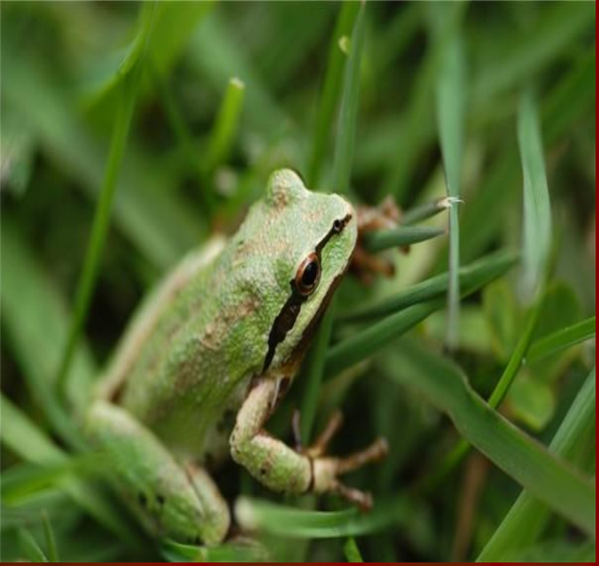
Poison dart frogs are normally bright blue, red or yellow in color. This frog has a change in its DNA sequence which resulted in a green body color.

- Highlight the evidence of mutations in the information above. Use yellow to highlight your evidence!

- Would this be a helpful mutation, harmful mutation, or one that doesn’t make a difference (a neutral mutation)?

- Why do you think so?

- How do you think mutations have caused the differences in Darwin’s Finches?

- EXEMPLARY OPTION: Can you give a different example of a mutation that can occur? Is it a helpful, harmful, or neutral mutation? WHY?

SCENARIO 2: Butterflies in the forest
Study the diagram below.
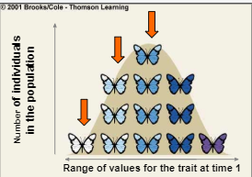
In a forest, there is a population of butterflies that are the following colors: white, light blue, blue, dark blue, and purple. They share similar genomes, but also are diverse in their codes for coloring.

- Highlight the evidence of genetic variation in the information above. Use yellow to highlight your evidence!

- Why is variation a good characteristic for a population?

- Predict what would happen to the population’s variation if it were more beneficial to be a darker colored butterfly:

- How do Darwin’s Finches show genetic variation?

- EXEMPLARY OPTION: Can you give an example of genetic variation in the human population? Describe it below:

SCENARIO 3: Bats and M. evenia
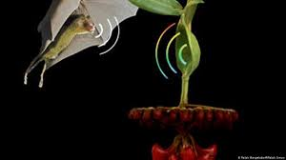
Bats and M. evenia, a flowering plant found in Cuba, have developed a symbiotic relationship. The type of symbiotic relationship they have is called mutualism. Mutualism means they both get something positive out of the relationship.The M. evenia has adapted to have leaves that are disc-shaped. The bats are brought directly to the plant because of their echolocation. They make a sound and it gets bounced back by the leaf (see the picture above). The bat loves to eat the nectar from the plant. The plant gets pollinated by the bat, and gets to reproduce.

- Highlight the evidence of Natural Selection in the information above. Use yellow to highlight your evidence!

- What adaptation has the plant obtained that allows it to attract the bat?

- Why is this adaptation beneficial?

- Predict: What is likely to occur to the leaves of M. evenia populations in the future? Explain your answer!

- Adaptation is important to natural selection. How do Darwin’s Finches show natural selection?

- EXEMPLARY OPTION: Lamarck described long necks in giraffes as if the giraffe made a choice to stretch its neck to be able to reach the leaves of tall trees and then passed on this trait to its offspring. Explain why this is WRONG and what ACTUALLY has created the trait. Rely on your knowledge of Natural Selection, Adaptations, Variation, and Mutations!

