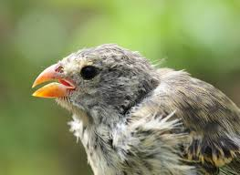
Galápagos Finches: Famous Beaks

Name:
Class Period:
STUDENT LEARNING OBJECTIVE:
Students will learn about what makes “Darwin’s Finches” so special.
INSTRUCTIONS:
- Read the article (PDF on our website with this assignment)
- Answer the questions below, using COMPLETE SENTENCES.
HINT: Read the questions prior to reading the article so you are aware of what answers you are looking for
QUESTIONS:
- How many species of finches have the Grants studied?

- How long have the Grants studied the finches?

- When did Darwin first visit the Galapagos?
- What did Darwin wonder about the finches?

- What was Darwin's first clue about the species evolving?

- What is the reason/process Darwin came up with that explains this evolution of the finches? Use the article to help you define this process.

- What did the Grants wonder?

- What did the Grants do to study the finches?

- What are four things that the Grants learned from their research?

