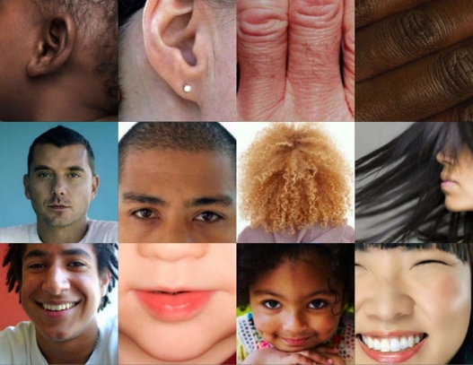
Learn. Genetics

Name:

Class Period:

STUDENT LEARNING OBJECTIVES:
- Students will review what traits are and how they are acquired
- Students will understand the connection between DNA and genes
- Students will understand the role of proteins in genetics
- Students will understand how mutations happen
- Students will understand that mutations can be helpful, harmful, and neutral
INSTRUCTIONS:
- Click on this link to watch the videos: https://learn.genetics.utah.edu/content/basics/
  - The videos are found in the Tour of Basic Genetics section at the upper right hand section of the website Learn.Genetics
- Watch all 5 videos and answer the questions from each video using COMPLETE SENTENCES!
- Save this assignment as a docx file (saved in Word) or a Google Doc file in your Google Drive
- Upload the completed assignment in CANVAS

VIDEO #1: “What are traits?”

Q1. Give 2 examples of inherited traits:
1)

2)

Q2. Where do we get inherited traits? Explain.

Q3. Give 2 examples of acquired traits (traits that only come from our environment)
1)

2)
Q4. Can your inherited traits be influenced by your environment? Given an example.

VIDEO #2: “What are DNA and Genes?”
Q1. Is DNA an atom or a molecule?

Q2. What are the “building blocks” of DNA?

Q3. What do larger units of DNA create?

Q4. What does a gene contain?

Q5. What is a genome?

VIDEO #3: ”What are Proteins?”
Q1. What is the role of proteins in our bodies? Explain.

Q2. What are proteins made of? Explain.

Q3. What does the type of protein in a cell do? Explain.

VIDEO #4: “What is Inheritance?”
Q1. When living things reproduce, what do they give to their offspring?

Q2. What are the differences between asexually reproduced offspring and sexually reproduced offspring?

Q3. How many copies of each gene do we have and what do those genes influence?

Q4. Do siblings get the same genes from each parent? Explain.

Q5. What is genetic variation? Explain how genetic variation works.

VIDEO #5: ”What is Mutation?”
Q1. What is a mutation and how does it happen?

Q2. How many variations of DNA do we have that are not present in our parents?

Q3. Are most mutations harmful, helpful, or neutral (doesn’t matter)?

