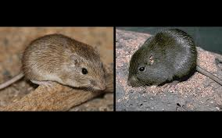
Rock Pocket Mice

Name:
Class Period:

INSTRUCTIONS:
- Watch the film “Rock Pocket Nice” https://youtu.be/wrTXvrKBlbc
- Complete the questions below using COMPLETE SENTENCES. Use evidence from the movie to back up your answers.
QUESTIONS:
- Where can we find the Rock Pocket Mice?

- What does the landscape look like?

- When did the last eruption occur in the area?

- What type of adaptation were the mice previous using to hide from predators? Explain.

- Why was their previous adaptation not helpful after the eruption occurred? Explain.

- What predators eat rock pocket mice?

- What experiments did the scientists do to understand the change in the rock pocket mice appearance? Explain the steps they took.

- What cause the rock pocket mice to have this new characteristic?

- Explain what a mutation is…

- How long did it take for natural selection to help the mice evolve in this area?
  - If the mice had a 1% competitive advantage it took ___________ years for _______________ % of mice to have the characteristic of ____________ ____________.
  - If the mic had a 10% competitive advantage it took ___________ years for the mice to have the characteristic of ______________ _____________.
  - Explain, why it takes years for natural selection like this to occur.

- What is the random component of natural selection?

- What sorts out what specific characteristics will give a species an advantage in their environment?

- Is there only one genetic way for a mutation to happen based on the rock pocket mice example? Explain.

- Why is evolutionary change never ending? Explain.

