5
Activity

PART THREE
Survival on Daphne Major
The scientists on Daphne Major observe everything on the island, and they keep a care- ful record of their data. In 1977 and 1978 they recorded a spell of over 500 days in which no rain fell. During this extremely dry period, many plants failed to produce seeds.
Investigate some measurements from the scientists’ ﬁeld notes. Turn their data into graphs to get a picture of what happened to the food supply and the ﬁnch popu- lation after the drought.

Work with a partner
Each team will need:
- Seed Abundance Graph
- Finch Population Graph

Tracking the Seed Supply
The observers on Daphne Major tracked seed abundance by ﬁrst measuring a square meter area of ground and then sifting through the soil to count every seed. This was done at many diﬀerent places to get an accurate count. They repeated the count every six months. Here are their data:

Field notebook seed count (measured in grams per square meter)
January 1976 | 7.5 | January 1977 8.0 | January 1978 2.0
July 1976 | 10.5 | July 1977 5.5 | July 1978 3.5

  - Using the entries from the ﬁeld notes, enter the data as a dot on the graph for each date. Connect the dots to complete the graph.
  - Review the Seed Abundance Graph. During what month and year did the seed supply shrink to its lowest amount?

  - During what month and year was the seed supply most abundant?

5
Activity

5
Activity

- Counting the Finch Population
The ﬁnches were counted every six months. Here are the data for the same period of time as the seeds were measured.
Field notebook ﬁnch count:

January 1976 | 1100 | January 1977 | 850 | January 1978 | 200
July 1976 | 1400 | July 1977 | 400 | July 1978 | 357

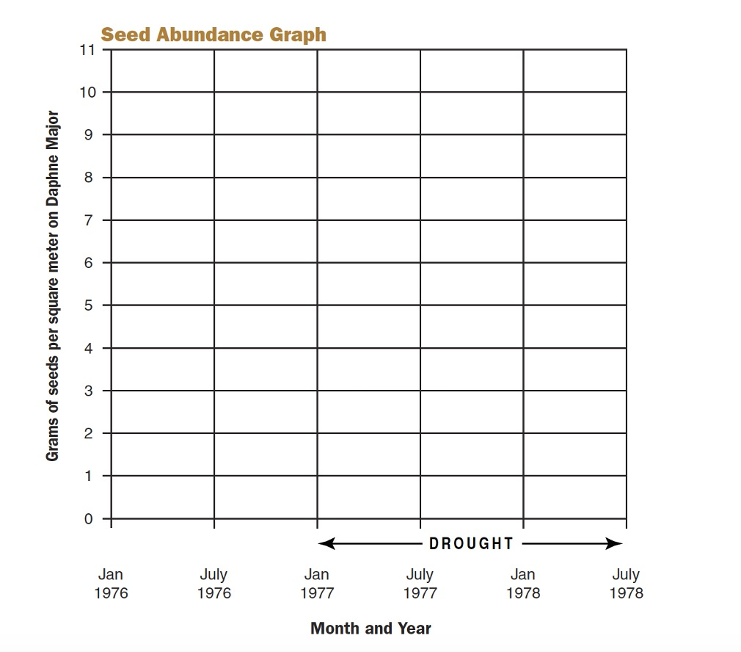
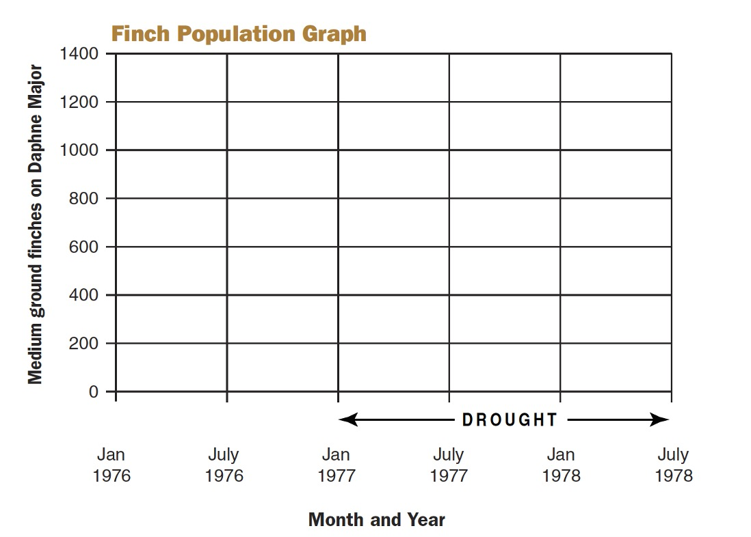

ANSWER THE FOLLOWING QUESTONS:

- Using the entries from the ﬁeld notes, enter the data as a dot on the graph for each date. Connect the dots to complete the graph.
- Review the Finch Population Graph. When was the finch population the lowest?

- When was the ﬁnch population the highest?

5
Activity

Think About Seeds and Finches Together
Compare the graphs side by side.
- What happened to the ﬁnch population when the seed supply shrank to its lowest amount? How do you account for this?

- When the seed supply increased, what happened to the ﬁnches?
How do you account for this?

Bigger Beaks, But Why?
When the team returned to Daphne Major, they found only one in seven ﬁnches survived the drought. When they measured the survivors, they found that most were ﬁnches with big beaks. Why do you think bigger-beaked birds survived bet- ter than the smaller-beaked birds?

Consider This
Beak size is a variation that is passed from parents to oﬀspring. When the new generation of young ﬁnches was measured in 1978, there were many more young birds with larger beaks. What happened?

5
Activity

PART FOUR
Be a science reporter
Write a short news story about the medium ground ﬁnches on the island of Daphne Major. Tell your readers about how the drought of 1977 led to changes in the char- acteristics of the ﬁnch population there. Based on what you have learned, explain why you think the ﬁnch population in the next generation had larger beaks after the drought.
P.S. Don’t forget the headline.

